CHAPTER 2
Requirements Specification

This chapter presents a comprehensive overview of the requirements and specifications necessary for the successful development and implementation of the system. It outlines both functional and non-functional requirements, provides detailed use cases, and describes the technical, operational, and business aspects that guide the system design. By establishing a clear understanding of the system’s expectations, constraints, and operational environment, this chapter serves as a blueprint for ensuring that the final product meets stakeholder needs and performs reliably under expected conditions.

2.1 Functional Requirements
Table 2.1 Functional Requirements
ID | Requirements Description | Priority
FR1 | The system shall allow officers to record and submit reports filed by complainants. | High
FR2 | The system shall generate a printed report or reference paper containing a QR code for complainants to track their cases. | High
FR3 | The system shall automatically send a digital copy of the receipt/reference to the complainant’s registered Gmail. | High
FR4 | The system shall store all report details securely in a centralized online database. | High
FR5 | The system shall allow officers and admins to generate weekly and monthly reports. | High
FR6 | The system shall provide a round robin feature to organize pending cases, prioritizing unfinished ones at the top of the queue. | Medium
FR7 | The system shall allow the admin to manage users (add, update, or remove officers). | High
FR8 | The system shall allow the admin to manage the database, including backup and recovery operations. | High
FR9 | The system shall automatically synchronize all data with the cloud database. | Medium
FR10 | The system shall generate printable templates for reports and summaries. | Medium
FR11 | The system shall allow data export in PDF or Excel format for documentation. | Medium
FR12 | The system shall send notifications for pending or updated cases to officers and admins. | MedIum
FR13 | The system shall allow complainants to track their report status online using the QR code or reference number. | High
FR14 | The system shall maintain an activity log for accountability and tracking of user actions. | High

2.1.1 Functional Requirements Descriptions
Item | Description
Req ID | FR1
Description | Report Filing
Priority | High
Functional Requirement Description | - The system shall allow officers to record and submit reports filed by complainants, including details such as name, address, incident type, and case description.
Acceptance Criteria | - Data Entry: Officers can input the complainant name, address, incident type, and case description.  - Data Validation: Required fields must be completed before submission.  - Data Storage: Successfully submitted reports are saved in the database and assigned a unique reference number.

Item | Description
Req ID | FR2
Description | QR Code Generation
Priority | High
Functional Requirement Description | - The system shall automatically generate a unique QR code for every filed report that can be printed on a physical receipt.
Acceptance criteria | - QR Code Creation: Each submitted report generates a unique QR code.  - Scannability: The QR code correctly links to the corresponding report details when scanned.  - Uniqueness: No two reports share the same QR code.

Item | Description
Req ID | FR3
Description | Email Receipt Distribution
Priority | High
Functional Requirement Description | - The system shall send a soft copy of the complaint receipt to the complainant’s Gmail immediately after submission.
Acceptance criteria | - Email Delivery: The complainant receives an email containing the case reference number, QR code, and basic report details.  - Timeliness: The email is sent within a short time after successful submission.  - Error Handling: The system displays a notification if email delivery fails.

Item | Description
Req ID | FR4
Description | Centralized Secure Storage
Priority | High
Functional Requirement Description | - The system shall store all report details securely in a cloud-hosted MySQL database.
Acceptance criteria | - Data Persistence: All reports are saved in the cloud database.  - Access Control: Only authorized users can retrieve data.  - Data Integrity: Records remain accurate unless modified by authorized users.

Item | Description
Req ID | FR5
Description | Role-Based Access Control
Priority | High
Functional Requirement Description | - The system shall allow officers and admins to generate weekly and monthly reports.
Acceptance criteria | - Report Generation: Officers and admins can generate weekly and monthly summaries.  - Accuracy: Generated reports reflect correct and updated database records.  - Print Support: Reports can be printed without formatting errors.

Item | Description
Req ID | FR6
Description | Round Robin Case Queue
Priority | Medium
Functional Requirement Description | - The system shall use a round-robin arrangement for pending cases, automatically reordering cases so older ones are prioritized and recently updated cases move to the bottom.
Acceptance criteria | - Queue Ordering: Older and unfinished cases appear at the top of the pending list.  - Update Handling: When a case is updated, it automatically moves lower in the queue.  - Automation: Queue reordering occurs without manual intervention.

Item | Description
Req ID | FR7
Description | User Management
Priority | High
Functional Requirement Description | - The system shall allow the admin to manage users (add, update, or remove officers).
Acceptance criteria | - Account Creation: Admin can add new officer accounts successfully.  - Account Update: Admin can modify officer details and roles.  - Account Removal: Removed accounts can no longer access the system.

Item | Description
Req ID | FR8
Description | Database Management
Priority | High
Functional Requirement Description | - The system shall allow the admin to manage the database, including backup and recovery operations.
Acceptance criteria | - Backup Execution: Admin can initiate database backups successfully.  - Recovery Validation: Restored data matches previously stored records.  - Access Control: Only admins can perform backup and recovery operations.

Item | Description
Req ID | FR9
Description | Cloud Synchronization
Priority | Medium
Functional Requirement Description | - The system shall ensure all data is continuously synchronized with the online database.
Acceptance criteria | - Data Sync: Reports are uploaded instantly to the cloud.  - Data Consistency: No records are missing or duplicated.  - Availability: Data is accessible from any authorized device online.

Item | Description
Req ID | FR10
Description | Printable Report Templates
Priority | Medium
Functional Requirement Description | - The system shall generate printable templates for reports and summaries.
Acceptance criteria | - Template Generation: Reports are generated using predefined templates.  - Formatting: Templates are properly formatted for printing.  - Print Compatibility: Reports can be printed directly from the system.

Item | Description
Req ID | FR11
Description | Data Export
Priority | Medium
Functional Requirement Description | - The system shall allow data export in PDF or Excel format for documentation.
Acceptance criteria | - Export Functionality: Users can export selected data as PDF or Excel files.  - Data Accuracy: Exported files contain complete and correct information.  - File Accessibility: Exported files can be opened without errors.

Item | Description
Req ID | FR12
Description | Notification System
Priority | Medium
Functional Requirement Description | - The system shall send notifications for pending or updated cases to officers and admins.
Acceptance criteria | - Notification Trigger: Notifications are sent when cases are pending or updated.  - Delivery: Users receive notifications through the system or via email.  - Accuracy: Notifications reference the correct case details.

Item | Description
Req ID | FR13
Description | Report Tracking
Priority | High
Functional Requirement Description | - The system shall allow complainants to track their report status online using the QR code or reference number.
Acceptance criteria | - Tracking Access: Complainants can enter their QR code or reference number.  - Status Display: The system displays the current and accurate report status.  - Security: Only valid reference numbers can retrieve report information.

Item | Description
Req ID | FR14
Description | Activity Logging
Priority | High
Functional Requirement Description | - The system shall maintain an activity log for accountability and tracking of user actions.
Acceptance criteria | - Action Logging: All significant user actions (login, update, delete) are recorded.  - Log Details: Each log entry includes user ID, action performed, and timestamp.  - Access Control: Only admins can view activity logs.

2.2 Non-Functional Requirements

ID | Requirements Description | Priority
NFR1 | The system shall respond to user requests within 2 seconds under normal load. | High
NFR2 | The system shall be available 99.9% of the time. | High
NFR3 | The system interface shall be intuitive and user-friendly for both officers and admins. | Medium
NFR4 | The system shall use HTTPS and secure authentication protocols to protect user data. | High
NFR5 | The system shall support offline data entry and synchronize automatically when the internet connection is restored. | Medium
NFR6 | The system shall be accessible on modern browsers (Chrome, Edge, Firefox). | High
NFR7 | The system shall scale to support up to 500 concurrent users. | Medium
NFR8 | The system shall support cloud-based and local data backup. | High
NFR9 | The system shall ensure all sensitive information is encrypted in transit and at rest | High
NFR10 | The system shall automatically generate data visualizations (bar graphs). | Medium
NFR11 | The system shall log and monitor all activities for system integrity. | High
NFR12 | The system shall be maintainable, allowing easy updates and feature enhancements. | Medium

2.3 Use Cases
Use Case ID | Name | Description | Actors
UC1 | Login | Authenticates the credentials of Officers and Administrators to provide secure access to the system’s modules. | Officer, Admin
UC2 | File Report | Complainant files a report through an officer. | Officer, Admin
UC3 | Generate Reference | System generates a printed reference paper with QR code. | Officer, Admin
UC4 | Email Receipt | System automatically emails a digital copy of the reference to complainant. | Officer, Admin
UC5 | Manage Cases | Officer reviews, updates, and marks cases as resolved. | Officer, Admin
UC6 | Manage Users | Admin adds, edits, or removes officers. | Admin
UC7 | Generate Reports | System generates weekly and monthly summaries. | Officer, Admin
UC8 | Data Entry | The Admin inputs and manages foundational system records | Admin
UC9 | Backup and Restore | Admin performs manual or scheduled data backups. | Admin
UC10 | Track Case | Complainant checks report status using QR code. | Officer, Admin
UC11 | Logout | Terminates the current user session to ensure the security and confidentiality of the anti-carnapping database. | Officer, Admin
UC12 | Activity Logs | Admin can track the changes in the system including admin activity | Admin
UC13 | Case Records | Provides the Admin with a centralized view of all historical and active carnapping case files. | Admin
UC14 | View Hotspot | Display case density visualization  on the dashboard. | Admin

2.3.1 Use Case Diagrams

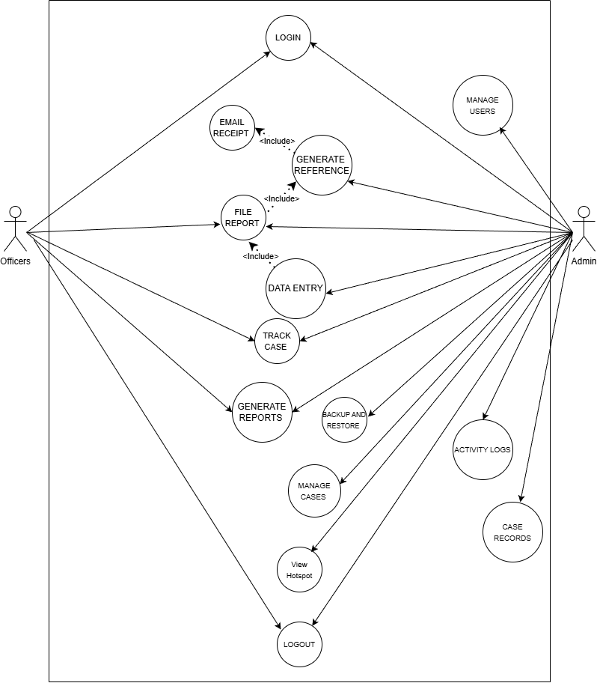

2.4 System Requirements
Hardware Requirements
- Client Device: Desktop/Laptop with at least 4GB RAM
- Cloud Server: 8GB RAM, SSD storage
- Printer: Standard A4 network printer
- Backup Drive (optional): 1TB external hard drive
Software Requirements
- Operating System: Windows 10 / Linux Ubuntu
- Web Browser: Chrome, Firefox, or Edge (latest 2 versions)
- Database: MySQL 8.0+
- Application Server: Node.js 18+ or PHP 8.2+
- Programming Language: JavaScript / PHP
- Framework: Laravel or Express.js
- Email Service: Gmail API or SMTP Integration
Network Requirements
- Stable Wi-Fi connection (minimum 10 Mbps)
- Secure SSL/TLS for web access

2.5 Business Rules
- Only authorized officers can file and update reports.
- Admins can approve or archive cases once completed.
- Reports must include the complainant’s name, incident type, and location.
- QR code references are automatically generated and unique.
- Weekly and monthly reports are automatically compiled every Sunday and end of the month.
- Only admins can delete records or modify user access levels.
- Backup is performed automatically every 24 hours.
- The system automatically notifies officers of pending cases.

2.6. Constraints
- Must use open-source technologies (e.g., MySQL, PHP, or Node.js).
- Must be operational by the first semester of SY 2026–2027.
- System must be hosted on a secure cloud platform (e.g., Firebase, AWS, or Azure).
- Must comply with local data privacy and cybersecurity laws.
- All documentation must be written in English.
- Must remain functional on low-bandwidth internet connections.

2.7 Assumptions
- All users have access to a modern browser and stable internet.
- Officers and admins are trained to use the system.
- Each police station has at least one functional printer and computer.
- Gmail integration will be available for sending receipts.
- Cloud storage and local backup will both be accessible.

2.8 Dependencies
- The system depends on an active MySQL database instance.
- The system depends on the Gmail API for automated email receipts.
- The system depends on the local network or Wi-Fi for access and syncing.
- Backup and synchronization depend on the cloud service configuration.
- Internet connectivity affects real-time features like email and case tracking.

